**Schema design of Ride Sharing Application**

1. create database Ride_Sharing_Application;
2. use Ride_Sharing_Application;
3. create table driver(

driver_id int primary key auto_increment,

name varchar(50) not null,

location varchar(50) not null,

contact bigint not null unique,

vechicle_type varchar(20) not null check(vechicle_type in ('Car','Bike')),

vechicle_no varchar(20) not null unique ,

rating double default 0 check(rating between 0 and 5),

is_available tinyint(1) default '1'

);

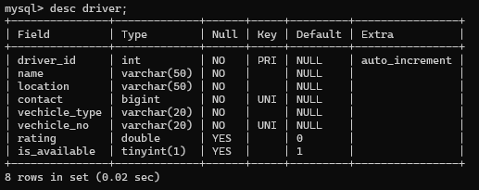

1. create table user(

user_id int primary key auto_increment,

name varchar(50) not null,

email varchar(50) not null unique check(email like '%_@_%._%%'),

contact bigint not null unique

);

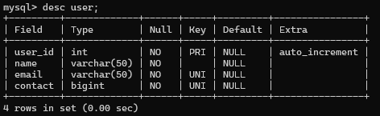

1. create table rides(

ride_id int primary key auto_increment,

user_id int not null,

driver_id int not null,

foreign key(user_id) references user(user_id),

foreign key(driver_id) references driver(driver_id),

start_location varchar(50)not null,

destination varchar(50) not null,

status varchar(20) not null check(status in ('Completed','In progress')),

fare double not null check(fare>=0)

);

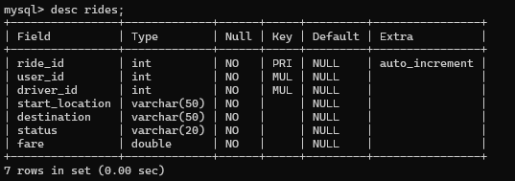

1. create table rating(

rating_id int primary key auto_increment,

user_id int not null,

driver_id int not null,

ride_id int not null,

foreign key(user_id) references user(user_id),

foreign key(driver_id) references driver(driver_id),

foreign key(ride_id) references rides(ride_id),

rating int not null default 0 check(rating between 0 and 5),

review varchar(50)

);

